Page size : A4 (21cm x 29.7cm) Margins : Top (3cm) / Bottom, Left and right (2.54cm)
Study on substrate surface able to increase loading of aqueous sample and generate consistent dried shapes for NIR analysis
( Title : Bold, 16 points, Times New Roman, Center )
( Blank space of 10 points )
Jinah Lee, Hoeil Chung
( Author names : Bold, 14 points, Times New Roman, Center, presenting author-underlined )
Department of Chemistry, Hanyang University, Seoul, Korea, 133-791
( Author affiliations : 12 points, Times New Roman, Center )
E-mail: jin0725@gmail.com
(Corresponding author E-mail : Underline, 12 points, Times New Roman, Center )
( Blank space of 10 points )
Abstract ( Bold, 12 points, Times New Roman, Align Text Left )
When aqueous liquid samples are analyzed using NIR spectroscopy, water absorption limits available spectral window for analysis of analytes and degrades signal-to-noise ratio of resulting spectra. Therefore, elimination of water absorption by evaporation of water could be preferable to improve accuracy of quantitative analysis and generation of reproducible dried patterns is a prerequisite. When a sample is dropped on a common substrate such as a glass window, the formation of droplet would not be inconsistent. Therefore, the use of hydrophobic surface could be advantageous in increasing loading amount and maintaining reproducible droplets. Here, we have evaluated three different substrates of polytetrafluoroethylene (PTFE) disk, perfluorooctyltrichlorosilane (FTS) - and amine - coated glass windows. Milks were dropped on these substrates and reproducibility in the shapes of dried droplets was compared with each other. For representative spectral acquisition, it was necessary to consider so called coffee ring effect, that generating inhomogeneous distribution of analytes on a surface after drying. For this purpose, a wide illumination scheme (area: 78.5 mm²) able to fully cover a dried spot was employed. Using the proposed scheme and the substrates, the determination of fat concentration in milks and discrimination between wild and transgenic tobacco leaves have attempted.
( 12 points, Times New Roman, Justify, 200 characters limit )
( Blank space of 10 points )
Graphical Abstract ( Bold, 12 points, Times New Roman, Align Text Left )
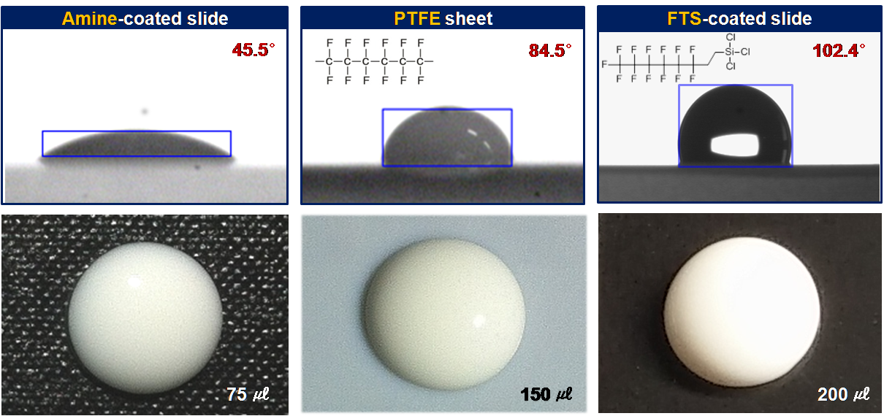
( Graphical Abstract image : Center )

Type of presentation intended: Choose one; Invited or Oral or Poster

